Ghement Statistical Consulting Company Ltd. © 2014
Web: info@ghement.ca E-mail: info@ghement.ca Phone: 604-767-1250

Performing the Mann-Kendall Test for Trend in R
To perform the Mann-Kendal test for trend in R, you can use the Kendall package developed by A.I. McLeod. This package can be installed in R with the command:
install.packages("Kendall")
Once the package is installed in R, you can attach it to each of your R sessions using the command:
require(Kendall)
The Kendall package has a function named MannKendall() which implements the non-parametric test for monotonic trend detection known as the Mann-Kendall test. (A monotonic trend can be either an upward trend or a downward trend.)
To illustrate the use of the MannKendall() function in R, we will use one of the data sets that comes with this package: PrecipGL. First, let us attach this data set to the current R session, view it and also read its help file:
data(PrecipGL)
?PrecipGL
View(PrecipGL)
We can see from the help file that this data set contains information on the annual precipitation levels for the entire Great Lakes for the time period 1900-1986.
How does R store the PrecipGL data set? We can use the str() command to find this out:
str(PrecipGL)
The output produced by str() indicates that R views this data set as a time series object:
> str(PrecipGL)
Time-Series [1:87] from 1900 to 1986: 31.7 29.8 31.7 33.1 31.3 ...
- attr(*, "title")= chr "Annual precipitation, 1900-1986, Entire Great Lakes"
Before implementing the Mann-Kendall test for trend to the PrecipGL time series, we should visualize this series using the R command below:
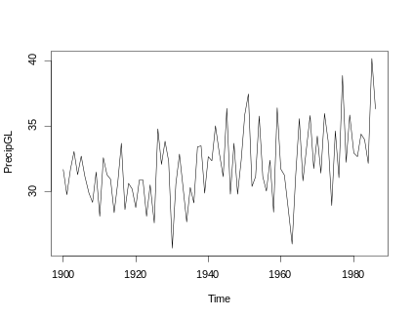
plot(PrecipGL)
The time series plot produced by R reveals the presence of an upward trend in the annual precipitation levels for the entire Great Lakes over the period of interest. To better see this trend, let us fit a nonparametric loess curve to the data using the lowess() function in R:

plot(PrecipGL, col="darkgrey")
lines(lowess(time(PrecipGL), PrecipGL), col="blue", lwd=2)

Here is the resulting plot, which reveals the underlying upward trend present in the data more clearly:
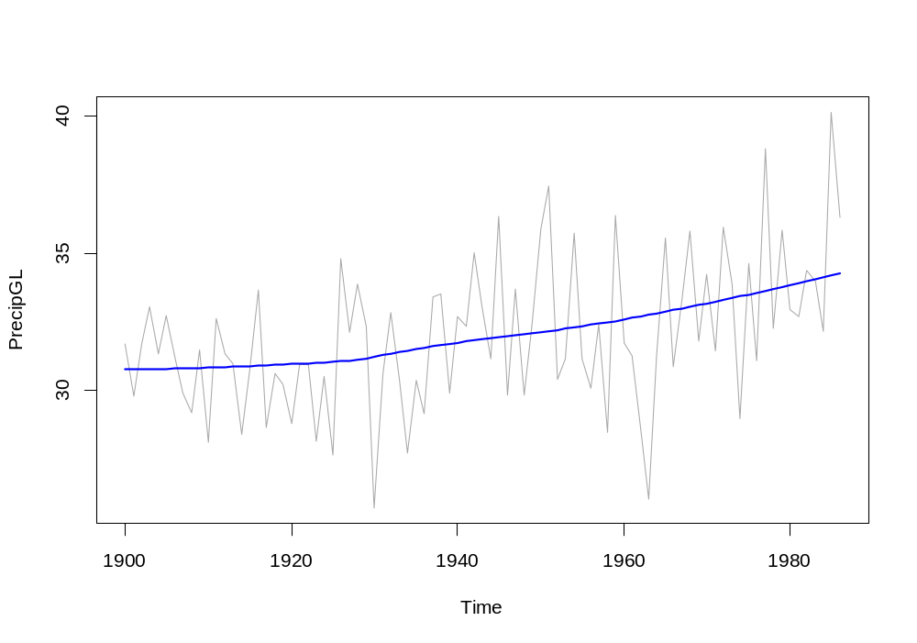
Before applying the Mann-Kendall test to the time series of annual precipitation levels, we should investigate whether the annual precipitation levels are serially correlated. If they are, we would need to use the Mann-Kendall test in conjunction with block bootstrapping in order to account for the serial correlation present in the annual precipitation levels. If they aren’t, we could apply the Mann-kendall test “as is”, without the need to correct the P-value of the test for serial correlation.

The presence of serial correlation among the annual precipitation levels can be investigated visually with the help of the acf() and pacf() functions in R, which compute the autocorrelation and partial autocorrelation corresponding to the time series of annual precipitation levels:
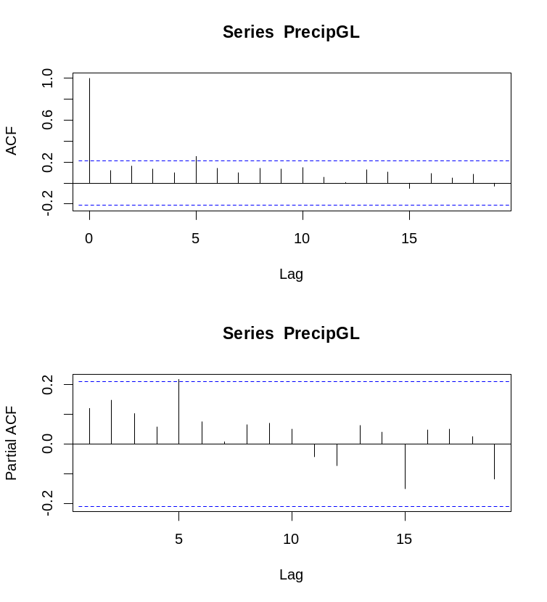
par(mfrow=c(2,1))
acf(PrecipGL)
pacf(PrecipGL)

Examining the autocorrelation and partial autocorrelation plots produced by R for the time series of annual precipitation levels suggests that the autocorrelation and partial autocorrelation present in this series do not appear significant. (Indeed, most of the vertical spikes in the ACF and Partial ACF plots produced by R fall within the horizontal band defined by the blue dotted lines beyond which autocorrelations and partial autocorrelations would be deemed to be significant.)

We can now apply the Mann-Kendall test ‘as is’ (i.e., without any corrections for autocorrelation) using the R command:
MannKendall(PrecipGL)
The output of this test produced by R is terse and reports just the tau value (i.e., Kandall’s tau statistic) and the 2-sided p-value for testing the hypotheses “Ho: no trend” versus “Ha: monotonic trend (upward or downward)”:
tau = 0.265, 2-sided pvalue = 0.00029208

For our example, the p-value associated with the Mann-Kendall test is statistically significant, suggesting the presence of a statistically significant upward trend in the annual precipitation time series.
The results of the Mann-Kendall test produced by R can be saved, printed and summarized using the commands:
> print(res)
tau = 0.265, 2-sided pvalue =0.00029208
> summary(res)
Score = 989 , Var(Score) = 74398.34
denominator = 3737.999
tau = 0.265, 2-sided pvalue =0.00029208
res <- MannKendall(PrecipGL)
print(res)
summary(res)

Note that the summary() command produces a more detailed output for this test by reporting the following quantities:
tau | Kendall's tau statistic
p-value | two-sided p-value
Score | Kendall Score (S)
denominator | denominator (D), such that tau=S/D
Var(Score) | variance of Kendall Score

If the autocorrelation and/or partial autocorrelation plots of the time series of annual precipitation levels would have revealed the presence of significant temporal dependence in the data across years, we could have used the Mann-Kendall test in conjunction with the block bootstrap method, as follows:
install.packages("boot")
require(boot)
MKtau <- function(z) MannKendall(z)$tau
tsboot(PrecipGL, MKtau, R=500, l=5, sim="fixed")

The R output produced by tsboot() is shown below:
> tsboot(PrecipGL, MKtau, R=500, l=5, sim="fixed")
BLOCK BOOTSTRAP FOR TIME SERIES
Fixed Block Length of 5

Call:
tsboot(tseries = PrecipGL, statistic = MKtau, R = 500, l = 5,
sim = "fixed")
Bootstrap Statistics :
original bias std. error
t1* 0.2645801 -0.2680149 0.09248485
For more details on how to interpret this output, you can refer to this link:
http://stats.stackexchange.com/questions/70593/understanding-the-output-of-a-bootstrap-performed-in-r-tsboot-mannkendall
To compute a 95% bootstrap confidence interval for the slope of the trend, use the boot.ci() function in the boot package:
boot.out <- tsboot(PrecipGL, MKtau, R=500, l=5, sim="fixed")
boot.ci(boot.out, type="perc")
Again, the reported confidence interval was built under the assumption that the serial correlation present in the time series of annual precipitation levels was non-negligible (which is not really the case for this series).
> boot.ci(boot.out, type="perc")
95% confidence interval for the slope of the upward trend detected in the series of annual precipitation levels, derived by assuming non-negligible serial correlation.
BOOTSTRAP CONFIDENCE INTERVAL CALCULATIONS
Based on 500 bootstrap replicates

CALL :
boot.ci(boot.out = boot.out, type = "perc")
Intervals :
Level Percentile
95% (-0.1670, 0.1878 )
Calculations and Intervals on Original Scale

